1. The Elo method is interesting, in which it provides a rating for each participant. The similarity between the Elo method and the Massey and Colley methods is that the ranking is based on the network formed by win-lose condition between each pair of competitors. The difference however, is that the Elo method generates a rating for every competitor, and in the long term, the rating indicates the competitor's ability.

I think the Elo method is better than the Massey and Colley methods. It is a bit weird when applying the Massey and the Colley methods on the same data set produce a different result, for example, the 2008 March MATHness. This difference is probably because Colley is not taking scores into account, but Massey does. I think the scores are necessary for calculating ranks.

2. The passage tells how essential and challenging cleaning data is. I had a similar experience when I was doing a physics experiment measuring gravitational acceleration, and there is a lot of variances in the process of measurements. So the data I obtained produced some strange results, such as the gravitational acceleration being 7.41, far away from its actual value, 9.81. Bad data do produce a bad result; however, the negative impact of the data might be magnified when external sources cited my research, and the incorrect result may spread to society!

Also, the information of a group of people involved in ensuring the quality of data is interesting. Members in this group have the respective division of the task, which shows how difficult the maintenance job is.

3.

(a)

$$\left(\begin{matrix}5 & -1 & -1 & -1 \\ -1 & 4 & -1 & 0 \\ -1 & -1 & 5 & -1 \\ -1 & 0 & -1 & 4\end{matrix}\right)\left(\begin{matrix}L \\ S \\ W \\ P\end{matrix}\right)=\left(\begin{matrix}3/2 \\ 0 \\ 3/2 \\ 1\end{matrix}\right)$$

(b)

L: 0.583333

W: 0.583333 (tie)

P: 0.541667

S: 0.291667

4.

Massey method:

===========================

Rank Rating Team

===========================

1 8.96489 Utah

2 6.01822 LA_Clippers

3 5.67156 Phoenix

4 5.56844 Milwaukee

5 5.27511 Philadelphia

6 4.81822 Denver

7 4.23511 Brooklyn

8 2.76489 LA_Lakers

9 2.25822 Dallas

10 2.14178 Atlanta

Predictability: 66.11%

Colley method:

===========================

Rank Rating Team

===========================

1 0.71135 Utah

2 0.69837 Phoenix

3 0.66527 Philadelphia

4 0.65228 Brooklyn

5 0.64642 LA_Clippers

6 0.64642 Denver

7 0.62631 Milwaukee

8 0.58148 Portland

9 0.58148 Dallas

10 0.58148 LA_Lakers

Predictability: 65.93%

Data visualization:

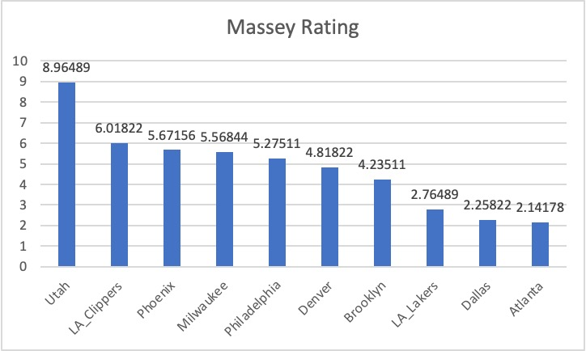

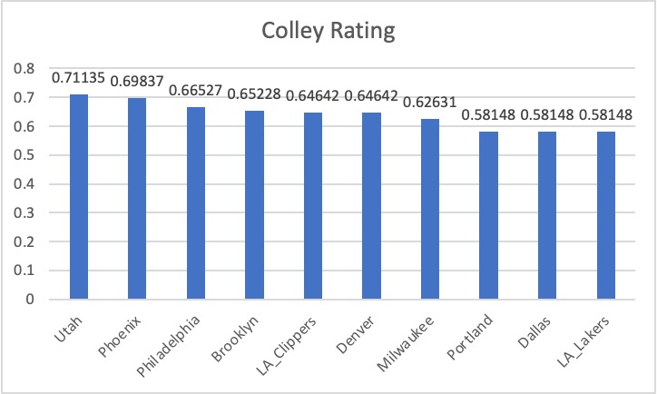

According to the two charts, teams' comparative ratings differ much in the Massey method than the Colley method. Utah in Massey rating is about 3 points higher than the second team, but it has only 0.2 points leading in the Colley rating. The Colley rating's 8th, 9th, and 10th teams have the same rating when approximating to 5 decimal places, but there is a difference in the Massey rating. Both methods have the same champion prediction. In terms of predictability, Massey has 66.11%, slightly above the 65.93% of Colley rating.

5. Colley and Massey's methods indeed fit better to my research direction. I would probably consider import and export data in economies; therefore, the Massey method is better. The sides on the graphs would have a number as the net export; meanwhile, the direction from country $i$ to country $j$ represents $i$ exports more to $j$. But I believe if my task is just ranking those countries' economic development, the content is a bit shallow, so I wonder how I can deepen my research question. Besides, I am curious if we are going to write codes ourselves because currently we just run your code with slight changes, but in terms of coding starting from nothing, it could be tricky.